Workshop Supply List
“Hill Country River”

Watercolor Paper: I will be doing a 1/2 sheet (15”x 22”)
On 300# Arches Cold Press.
NOTE: 140# is much lighter and will warp with the large wash on the water.

Watercolors: Bring what you have!

** NOTE: I use mostly Holbein Watercolors

I will have these colors with me.

Burnt Sienna
Burnt Umber
Cobalt Blue
Jaunt Brilliant #1 (Holbein)
Naples Yellow Italian
(Holbein Gouache)
Neutral Tint (Holbein)
Sap Green
Cadmium Green Deep & Light
Permanent Red
Permanent Yellow Light

Titanium White Gouache
Sepia

Raw Sien Raw Umber

Raw Seina
Yellow Ochre

Brushes: 1”+ Wash brush
1 large round #12 or #14

2 medium size round #4, #6
2 or 3 smaller rounds - #2, #3
Old brushes for applying Masking Fluid

Supplies: Paint Pallet (I use a Butchers Tray, enamel)
Water Bucket (Available at WAS-H)
Pebeo Drawing Gum (the one that is “IRRITANT”)
Rubber Cement Pickup
Bestine Rubber Cement Thinner
*NOTE: I will be furnishing this.

Reference Photo

If you want a glossy photo to work from
8 ½“ x 11” = $5.00 OR 11”x 17 = $10.00

Subjects: I will be bringing the image and a projector to project the subject onto your paper. It really saves a lot of time.

If you want a glossy photo to work from let me know
8-1/2 “ x 11”= $5.00 each.
11x17 = $10.00

Masking Pebeo Drawing Gum – Liquid Frisquet

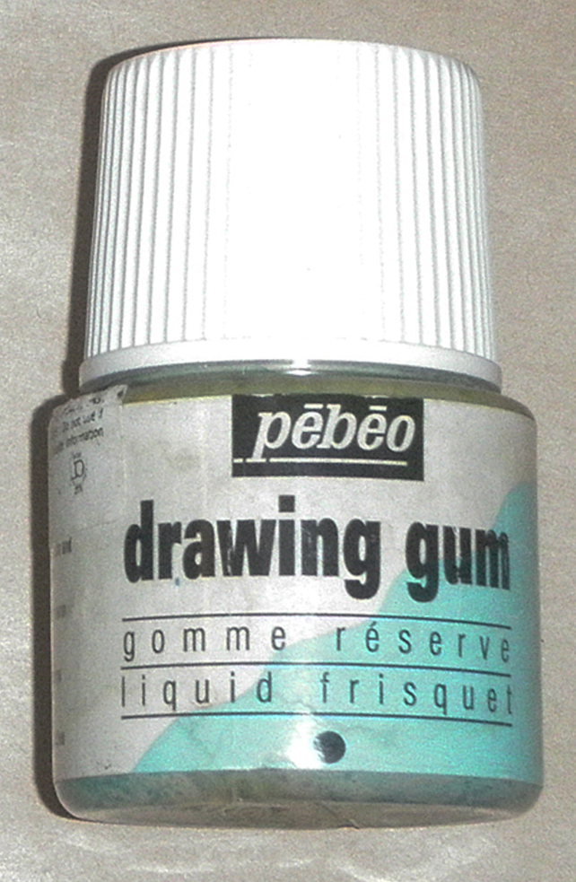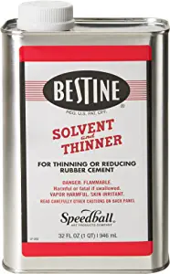

Rubber Cement Pickup
Bestine Rubber Cement cleaner
PS: I will furnish this at my workshop

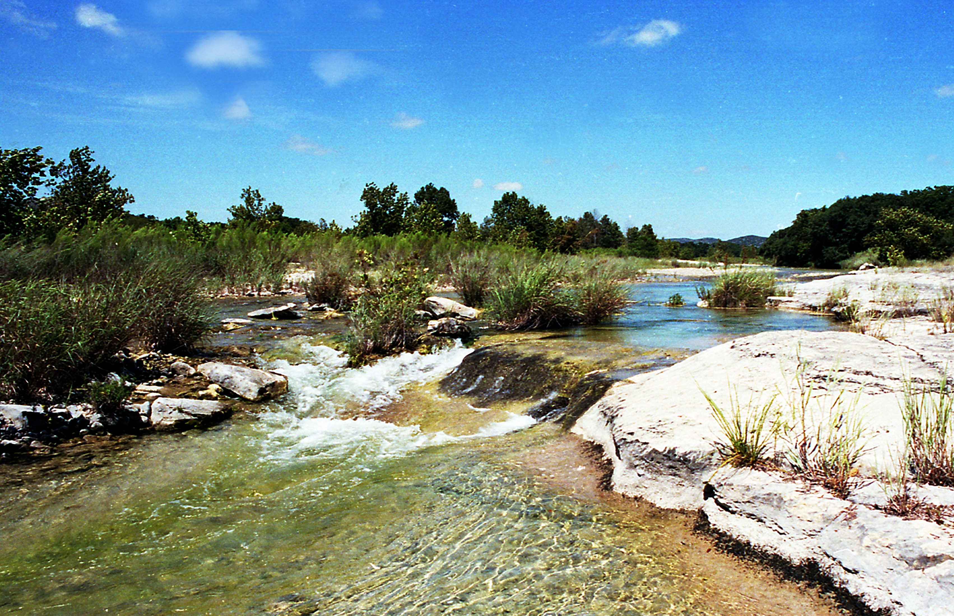
Hill Country River Reference Photo

