Using the Mobile App for Wild Apricot (WASH Website)
- On an iPhone, go to the App store and search for Wild Apricot. For Android phones, go to Google Play apps.
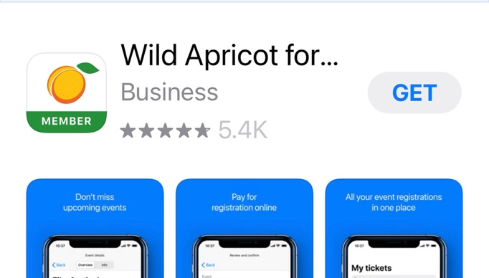
- Select Wild Apricot for Members (not administrators):
Notice the green bar along the bottom of the icon. It should say Member.
- Download the app and then open and login with your website personal email & password.
- There are 4 menu choices along the bottom. Just tap to see.
- Members connects you to the WASH member directory. You start with this search window and then if you tap on a member’s name, it opens the directory info on them.

- Events connects you to the current & upcoming workshops and classes. They are in order by date, but there is also a search window. You can see more details about the event by tapping on the title. You can register for a class for yourself from here, but the list of people registered and/or wait list are only viewable by website administrators, like Education Director.

- My Tickets is a handy way to see events YOU have registered for.

- My Profile on the bottom right shows all of your member information, more than the directory.

