How to prepare a photograph for our online gallery show:
- Crop your image.
    - Artwork only
    - Exclude mat, frame, wall, etc.

- Size your image. (see “How to resize images” below)

- Name each file correctly:
  - Last name, First name – Title of Art Work.jpg
  - Example: Mossman, Laura – Pretty Little Painting.jpg

4. Email file(s) to admin@watercolorhouston.org

HOW TO RESIZE IMAGES
Use these dimensions/format:
1. File Dimensions: 800 pixels on the longest side
2. File Resolution: 72 pixels/inch
3. File size: under 1MB
4. File type: JPG or JPEG

Here are directions for resizing on three different computer systems.
MAC COMPUTER, USING PREVIEW
1. Select the image file you want to resize. Right-click and select Open with Preview
2. Go to Tools, then Adjust Size
3. Choose Fit Into Custom, and resize the image to 800 pixels on the longest side
4. Make sure resolution is 72 pixels/inch
5. Scale Proportionally and Resample Image should be checked
6. Click OK

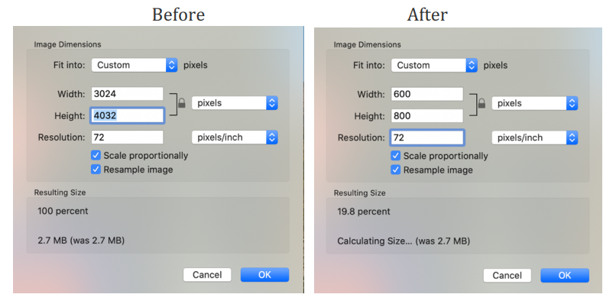

PC COMPUTER, WINDOWS 10
1. Select the image you want to resize, right click on picture and select Edit
2. On the Toolbar, click Resize and change to Pixels
3. Resize to 800 pixels on the longest side
4. Check Maintain aspect ratio
5. Quality should be at 80 Before After
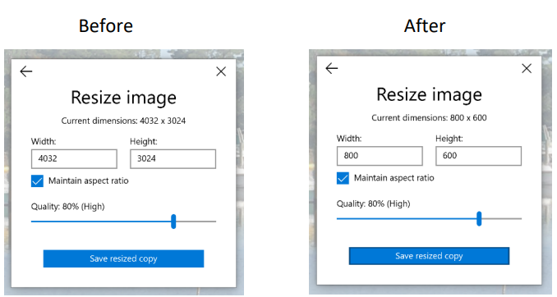

PC COMPUTER, Windows versions older than 10
1. Select the image you want to resize, right click on picture and select Edit.
2. On the Toolbar, click Resize and change to Pixels.
3. Resize to 800 pixels on the longest side.
4. Check Maintain aspect ratio.
